Exp-23

You cloned a repository earlier, and now another collaborator has made changes to it. You need to pull the latest changes from GitHub to keep your local copy up to date.

Tasks:

• Clone a repository (from previous questions).

• Ask a collaborator to make a change and push it to the GitHub repository.

• Use git pull origin main to pull the latest changes.

• Verify that the changes made by your collaborator appear in your local repository.

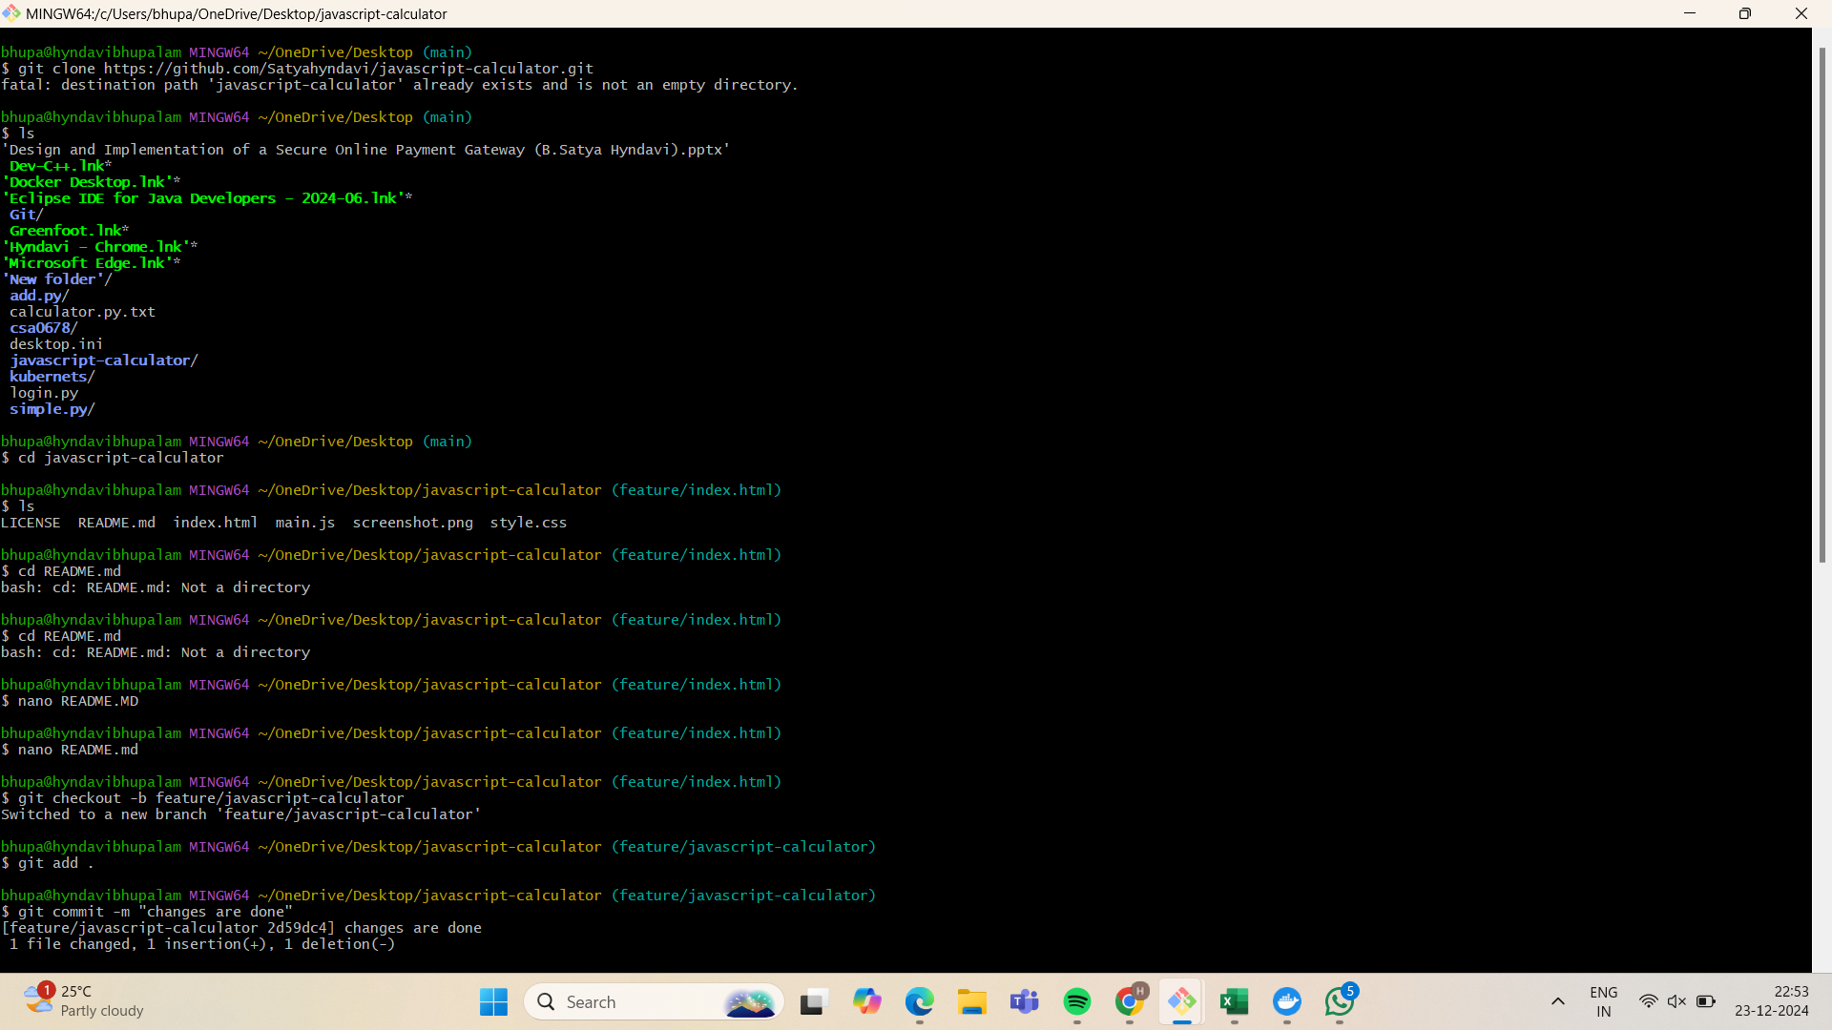

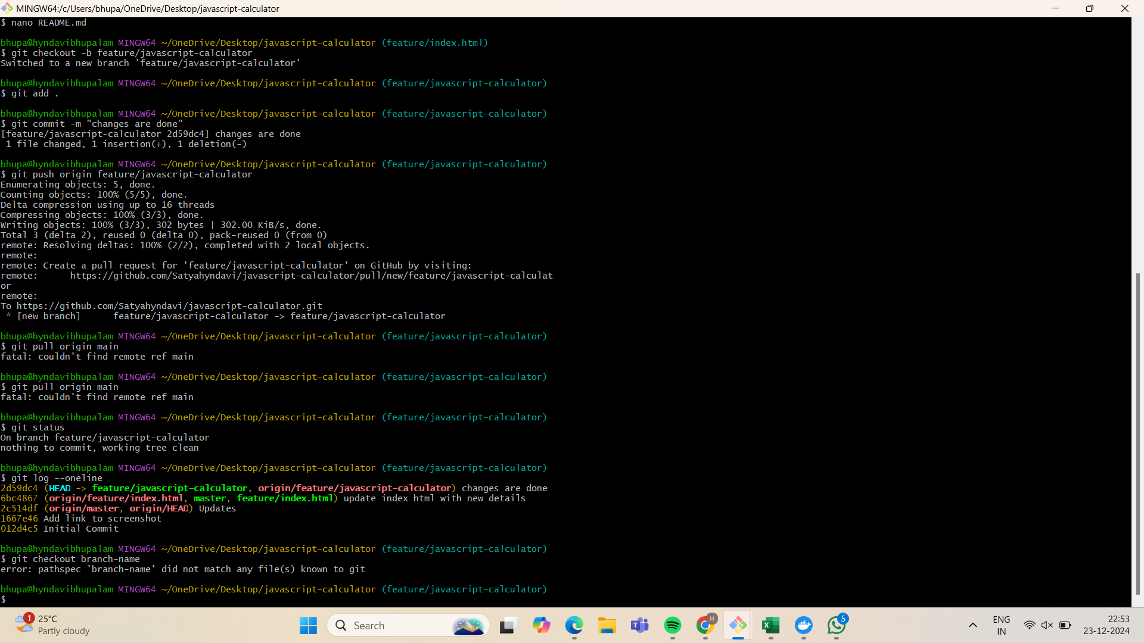

Exp-24

In your GitHub repository, create a new branch called feature-login. Implement a simple login function in a login.py file. After completing the function, create a pull request to merge feature-login into the main branch. Tasks:

• Create a new branch feature-login.

• Add a login.py file with a simple login function.

• Commit the changes and push them to GitHub.  
 • Create a pull request from feature-login to main and merge it.

